CMSC204

Assignment 1 – Design (Final)

UML Diagram:

**Screenshots –**

LengthException:

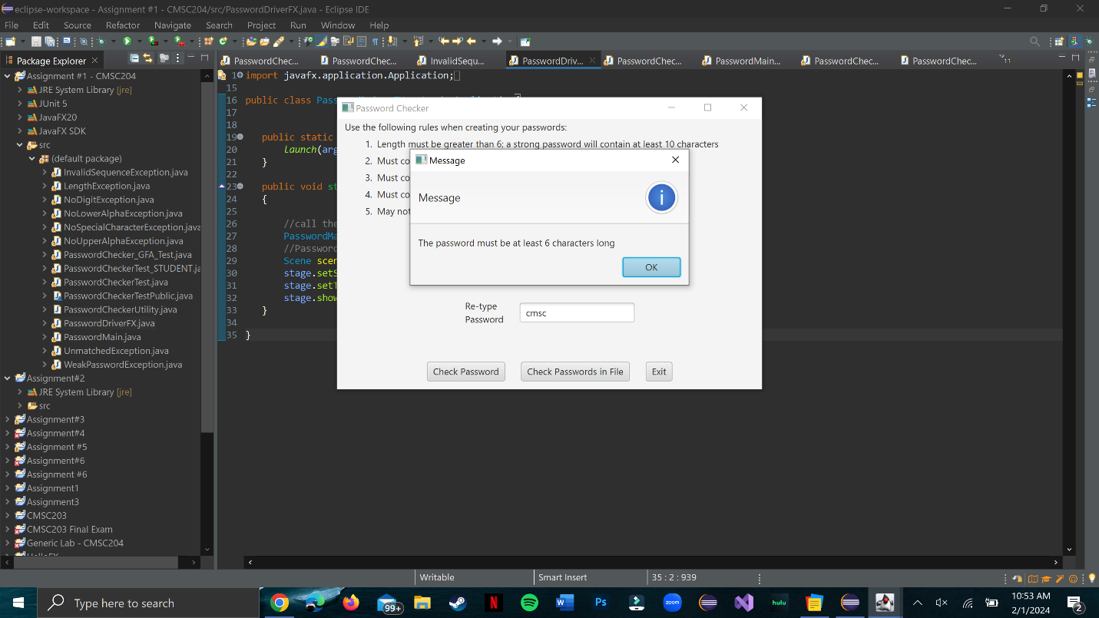

NoUpperAlphaException:

NoLowerAlphaException:

NoDigitException:

NoSpecialCharacterException:

InvalidSequenceException:

WeakPasswordException:

Check Passwords in File:

GitHub:

Lessons learned & learning experience:

* What have you learned?

While doing this project, I learned how to use Pattern & Matcher. The videos provided in the Assignment document were helpful.

* What did you struggle with?

The only thing I struggled with was the getInvalidPasswords() method. However, I did spend a lot of time at the Ackerman STEM Learning Center which helped me a lot.

* What would you do differently on your next project?

I would try and start my next project earlier. I did start this one early and was able to complete it 5 days before the deadline. But I know that assignments keep on getting complex and require a lot of time for thinking.